What is Asthma?
Asthma is a chronic (long-term) lung disease affecting people of all ages. It is caused by inflammation and muscle tightening around the airways, which makes it harder to breathe.
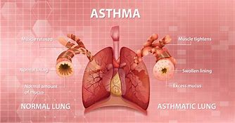
Symptoms can include coughing, wheezing, shortness of breath and chest tightness. These symptoms can be mild or severe and can come and go over time.
Asthma a common condition that affects more than 300 million people worldwide, with 5.4 million people in the UK receiving treatment it. Approximately 1 in 12 adults and 1 in 11 children are affected. Although it can be a serious condition, it can be managed with the right treatment.

Medicines that can help your asthma

An inhaler is a device containing a medicine that you take by breathing in (inhaling). Inhalers are the main treatment for asthma and help to control asthma symptoms.

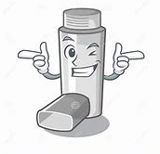

Preventer inhalers can be different colours and shapes. You take them every day even if you feel well. They make your airways work better.

Reliever inhalers are usually blue. You take them when your asthma feels bad. They make it easier to breathe. Keep your blue inhaler with you all the time

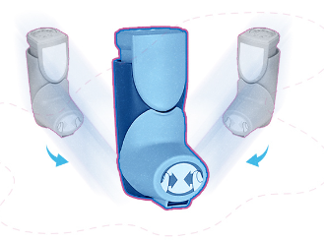
Maintenance and reliever therapy (MART) uses a combination inhaler that combines a steroid and a bronchodilator medicine called formoterol. You can ask your GP, asthma nurse or pharmacist to find out what combination inhaler you are using.

Asthma attack

Sometimes your asthma might get worse.
You are having an asthma attack if any of these things happen:
- You need to use your blue inhaler a lot .
- Your chest feels tight .
- You are coughing and wheezing a lot .
- You cannot breathe well .
- It is hard to talk.

What to do if you are having an asthma attack
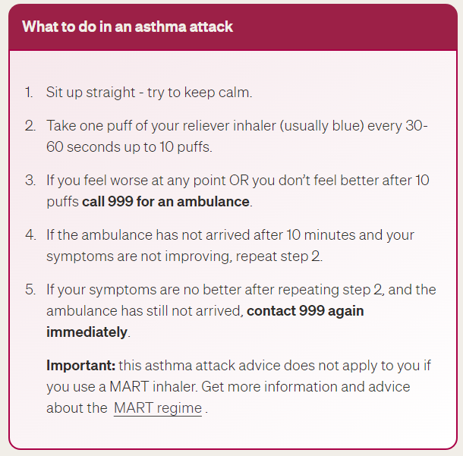

What can make your asthma worse?

Some things can make your asthma worse and most people have more than one thing.

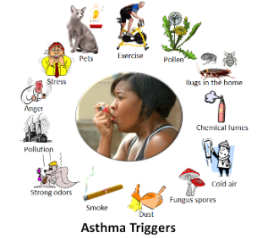

Stay healthy

Eat well – Eating well is important for your overall health. A well-balanced diet with the right vitamins and minerals can help you stay strong and fit. It can also help you prevent chest infections and keep your lungs healthy.
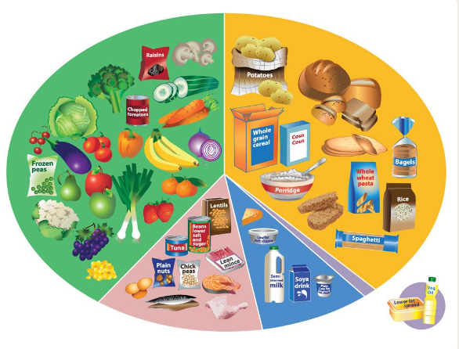

For advice on eating well, you can visit Eat well - NHS (www.nhs.uk)

Exercise – Regular movement helps to increase the strength of the muscles around your body, including your lungs.
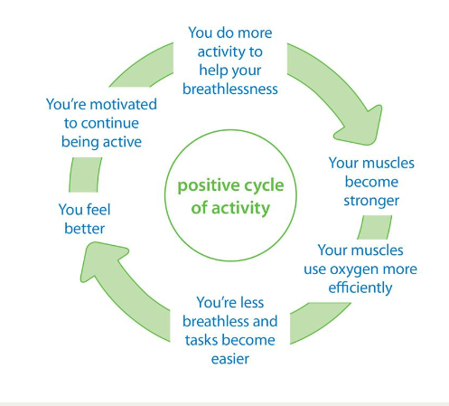
Light, regular exercise, including walking and cycling are good for you. Instead of taking the car or the bus, try to use active transport like walking and cycling as this also reduces air pollution.

Air pollution - It is important if you have asthma to be aware of air pollution levels and what to do if those levels are high.

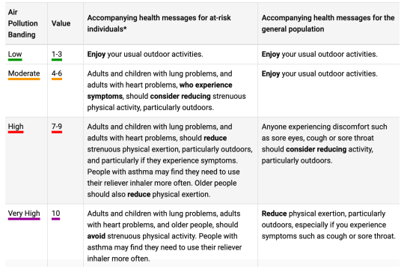
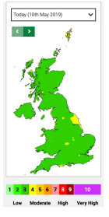

You can check levels of air pollution in your local area by visiting Home - Defra, UK

Stop smoking (including vapes)- Everyone knows smoking is bad for the lungs, but if you have asthma and smoke the lungs are damaged faster and the risks of smoking higher.
NHS stop smoking services help you quit - NHS (www.nhs.uk) provides information on stopping smoking.

Avoiding damp and mould – Damp and mould can be an astha trigger. Improving indoor air quality | Asthma + Lung UK (asthmaandlung.org.uk) for practical advice on avoiding damp and mould

Annual reviews

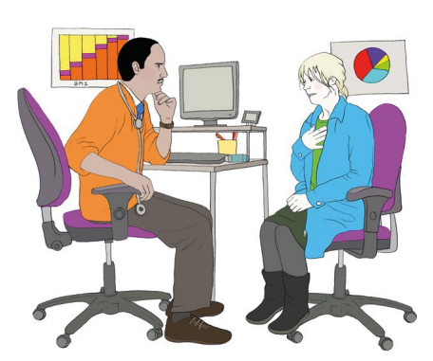
Every year you should go to your doctor for an asthma review. An asthma review is a check up for your asthma. You will be invited for your annual review by your Doctor / Nurse.
If you haven’t had a review, you can request one here *insert askmygp*

Digital health passport app

The Digital Health Passport is a mobile app for children, young
people and their grown-ups.
Your asthma care at your fingertips:
• Carry your asthma plan with you
• Know what to do in an attack
• Remind yourself to take your medicines
• Get alerts for pollen and pollution where you are.

Asthma (who.int)
Prevalence | Background information | Asthma | CKS | NICE
What is asthma? | Asthma + Lung UK (asthmaandlung.org.uk)
Asthma Inhalers: Names and Types | Patient
Preventer inhalers | Asthma + Lung UK
Reliever inhalers | Asthma + Lung UK
Maintenance and Reliever Therapy (MART) | Asthma + Lung UK
Asthma attacks | Asthma + Lung UK
Things That Make Asthma Worse - KnowYourAsthma.com
Eating well with a lung condition | Asthma + Lung UK (asthmaandlung.org.uk)
Physical activity and your lungs | Asthma + Lung UK
Microsoft Word - AIR POLLUTION.docx (beatasthma.co.uk)
Managing my Asthma - Beat Asthma

